**What is the main cause for rejection of CDR Report?**

CDR represent competency demonstration report is one of the crucial very mandatory report for those who are hoping to migrate to Australia. Despite the fact every individuals are very conscious about the CDR report writing, there might be chances for CDR report to get rejected. There are some of the reasons [CDR report rejections](https://writemycdr.com/2019/05/16/reasons-for-rejection-of-cdr-report-by-engineers-australia/) which is listed below:-

* Plagiarism content
* Career episodes too technical
* Word count & not including problem statement
* Selections of absurd project
* Vague Summary statement
* Misguided CPD writing

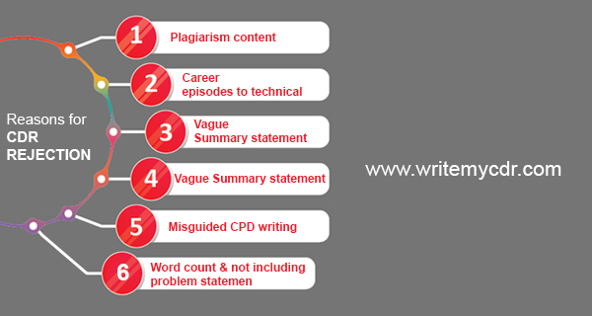

These above points are the main reasons that lead to rejections so make sure if you have any doubt you can hire an agent for [CDR proofread and CDR review](https://writemycdr.com/2019/05/16/who-can-proofread-edit-review-already-prepared-cdr-report/). In other case, there are so many CDR report sample which you can take as a references. In case you decide to get help from CDR writing services provider, you have to consider many things before [choosing CDR writing service](https://writemycdr.com/2019/05/06/things-to-consider-while-choosing-cdr-writing-service/). For instance, you can choose [writemycdr](https://writemycdr.com) which is fully aware of the professional CDR format as per the guidelines of Engineers Australia (EA) and have high acceptance rate.